**SS INSTITUTE OF TECHNOLOGY**

**LOGIN PAGE**

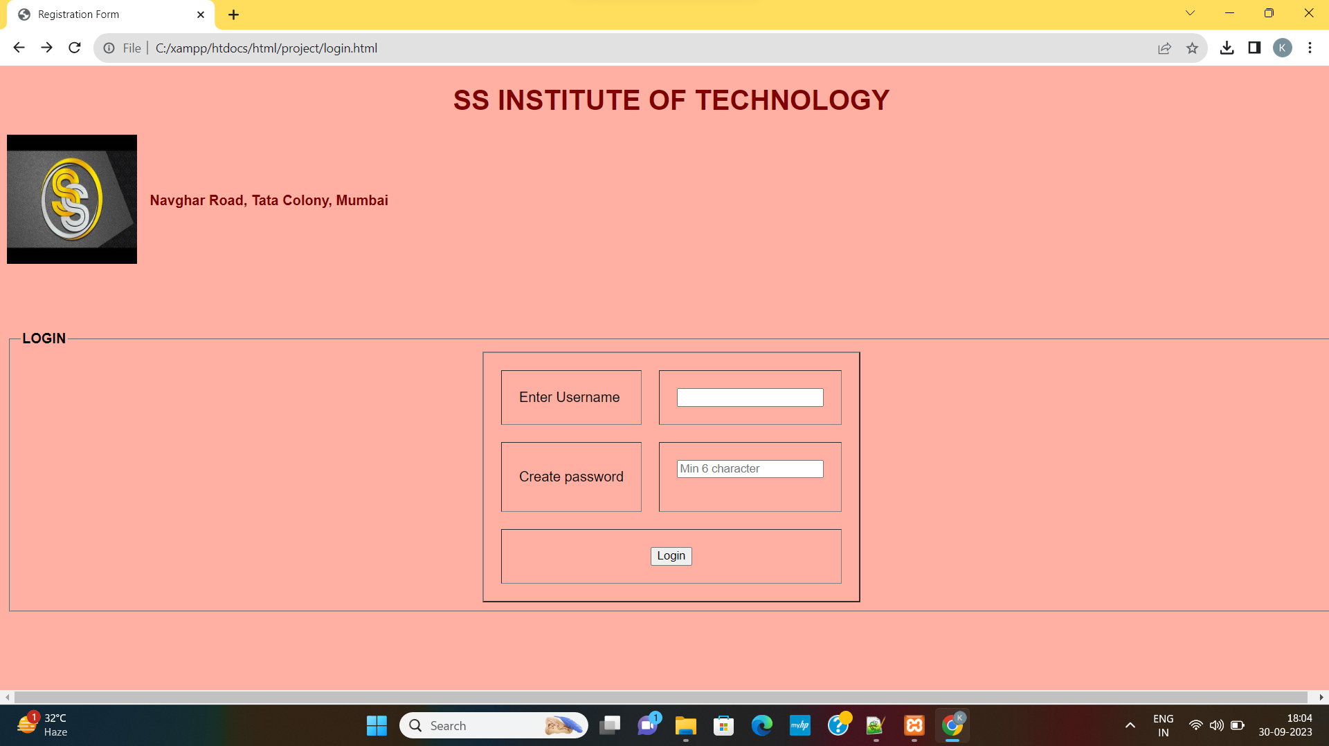

**COLLEGE DATA**

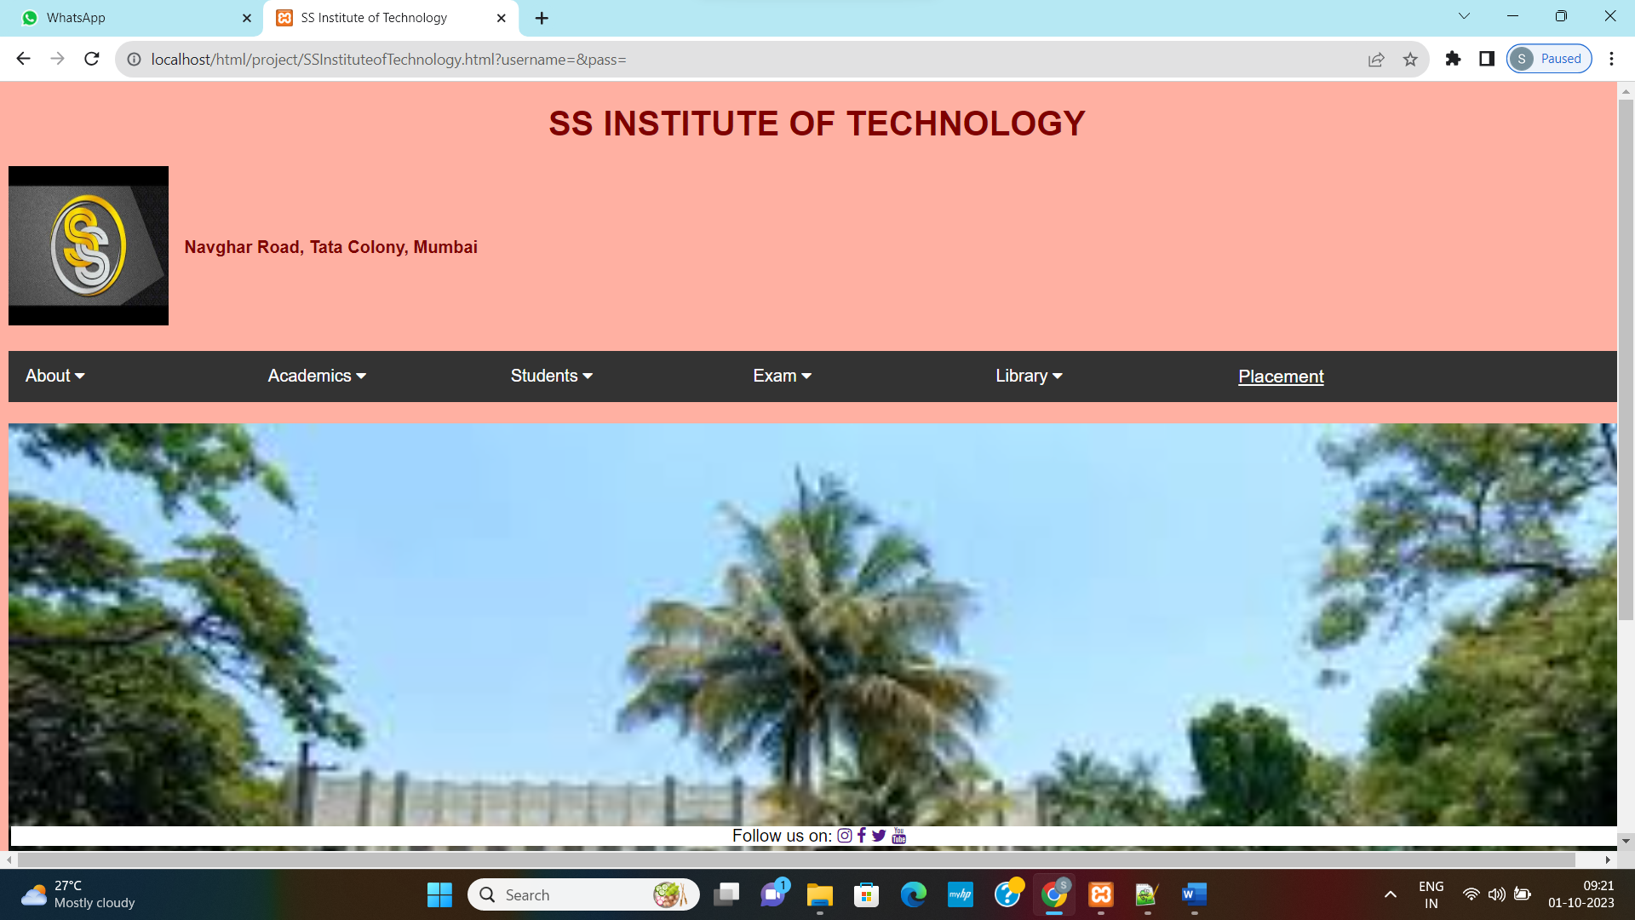

**COLLEGE INFORMATION**

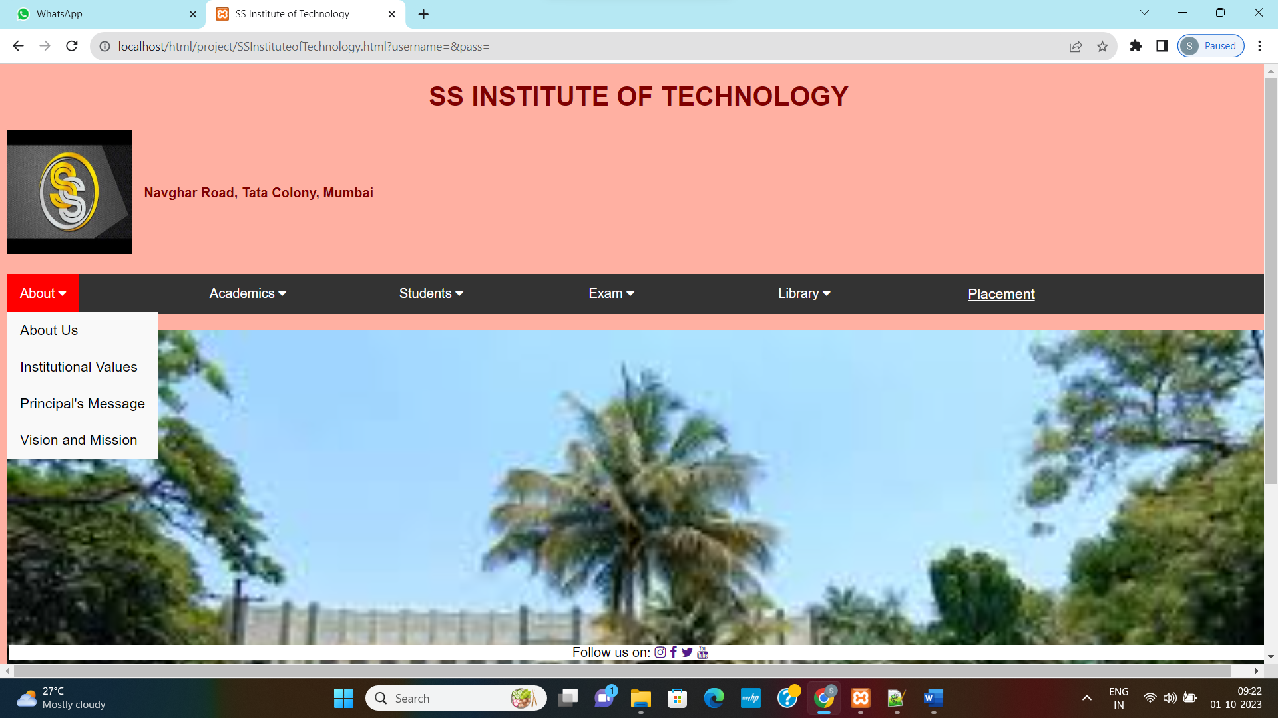

**ABOUT US**

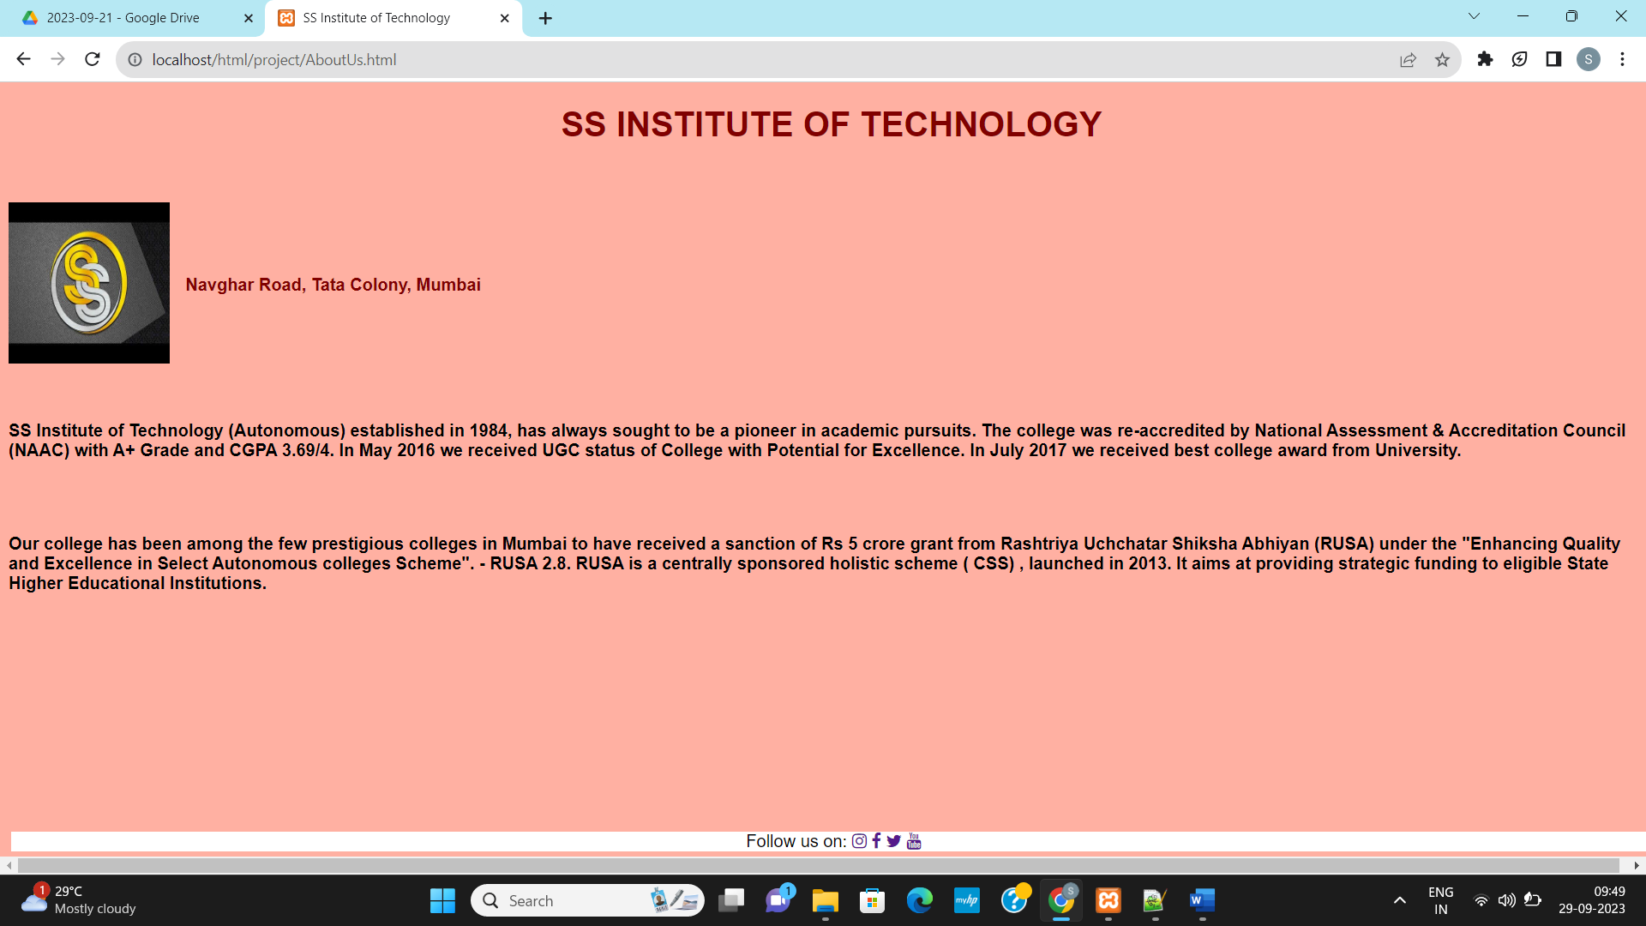

**INSTITUTIONAL VALUES**

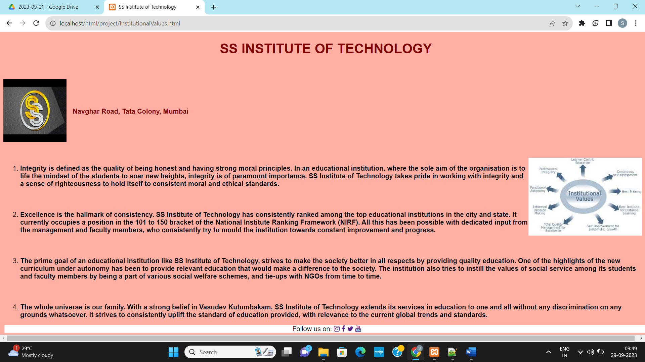

**PRINCIPAL MESSAGE**

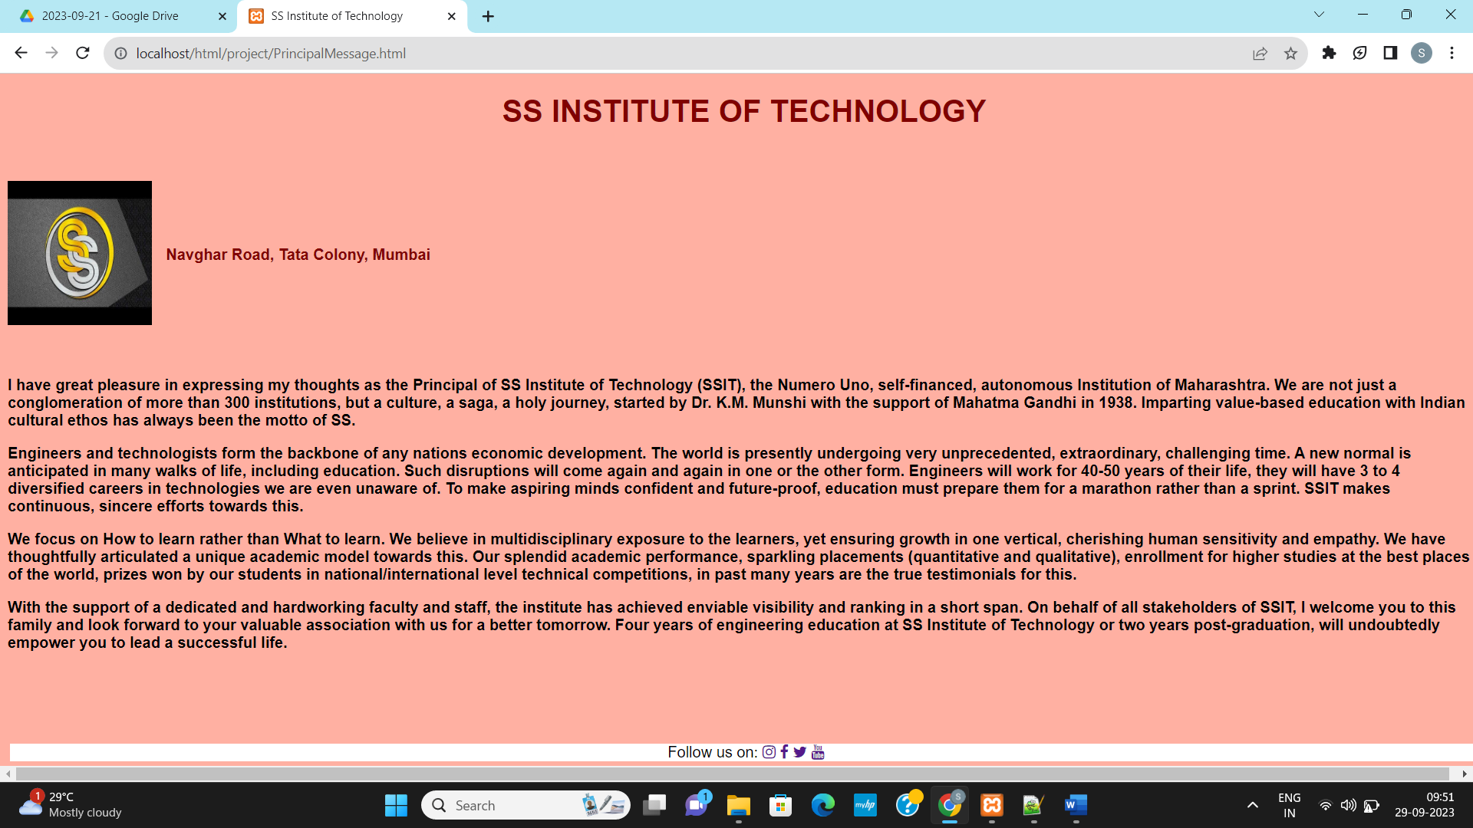

**VISION AND MISSION**

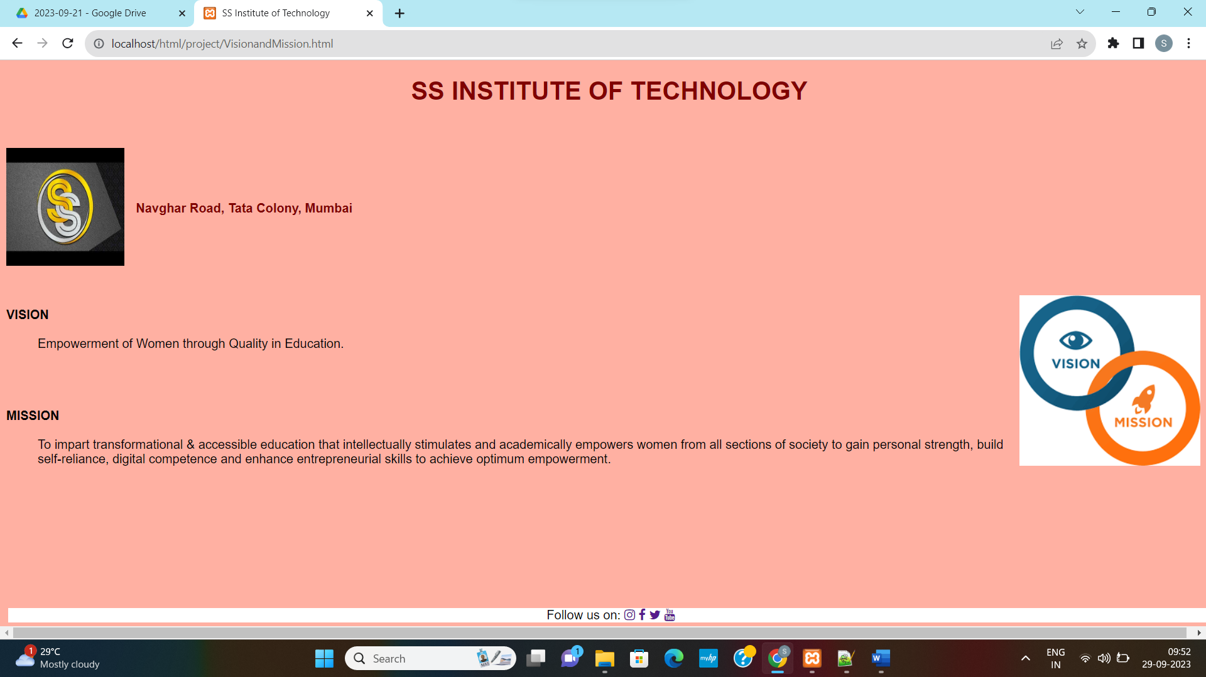

**ACADEMICS**

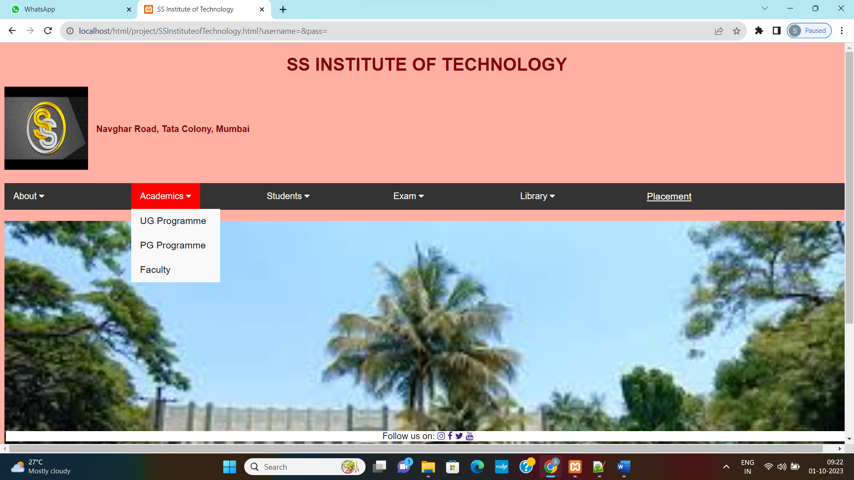

**UNDERGRADUATE COURSES**

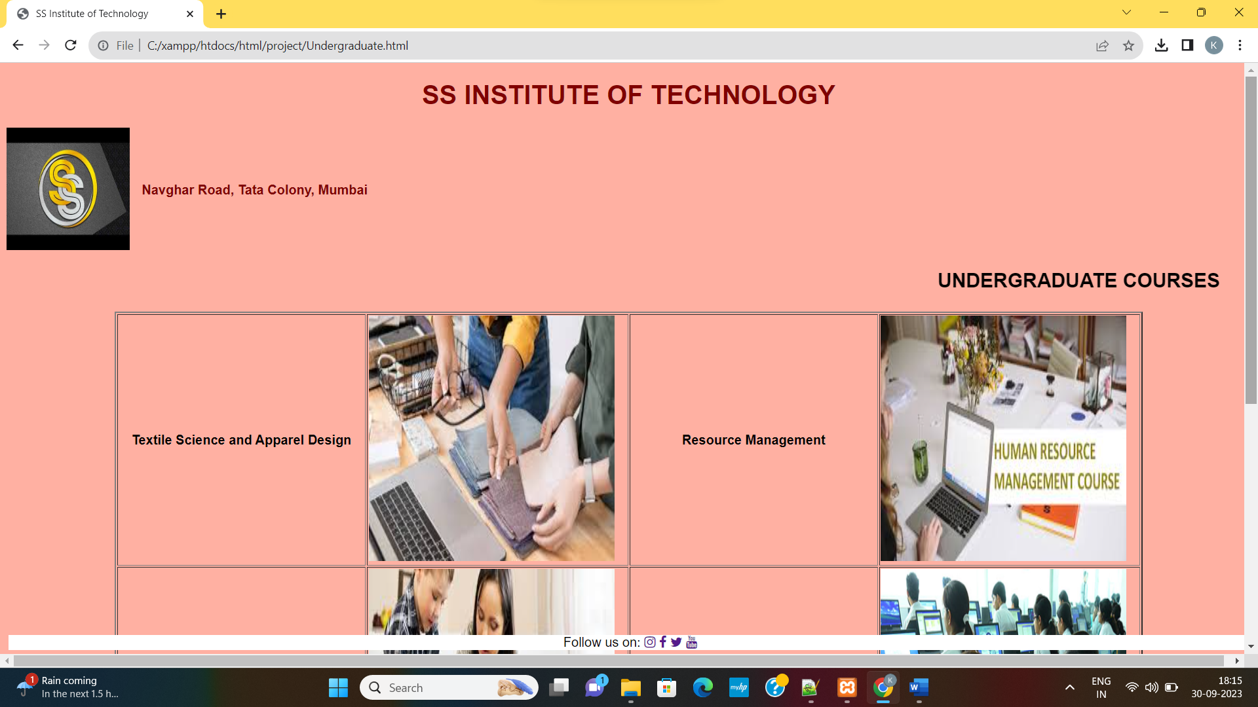

**POSTGRADUATE COURSES**

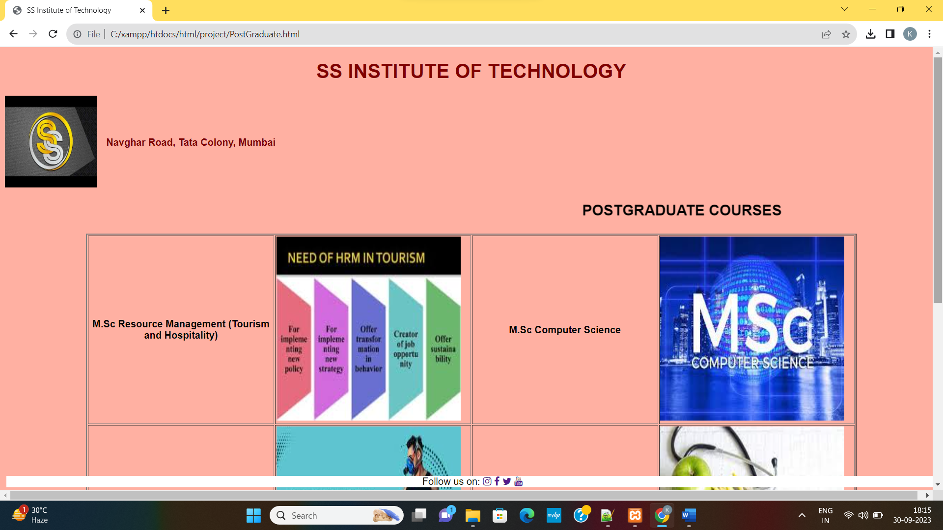

**FACULTY**

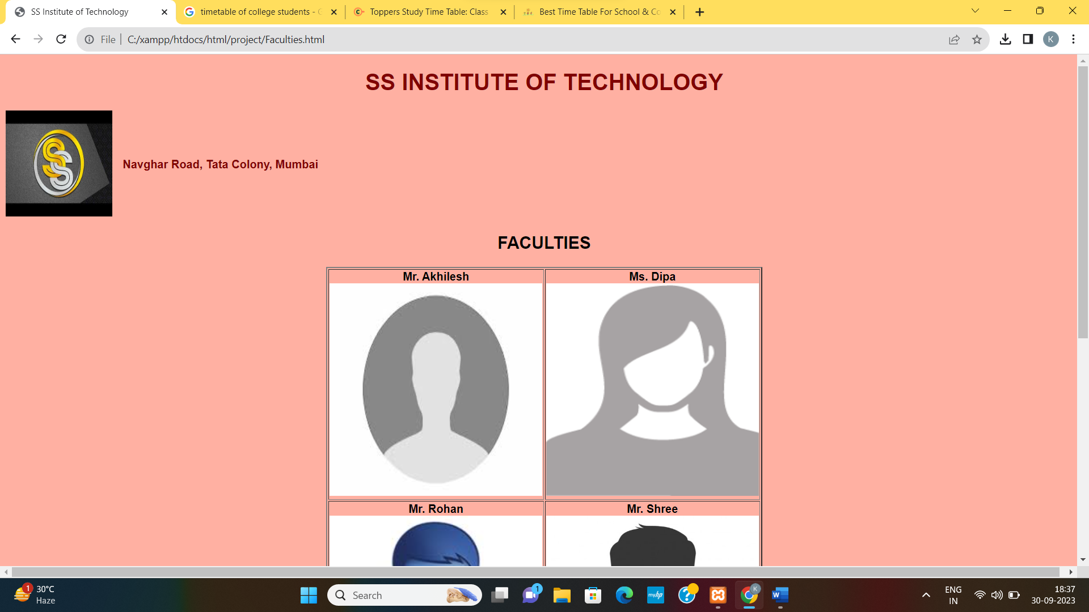

**STUDENTS**

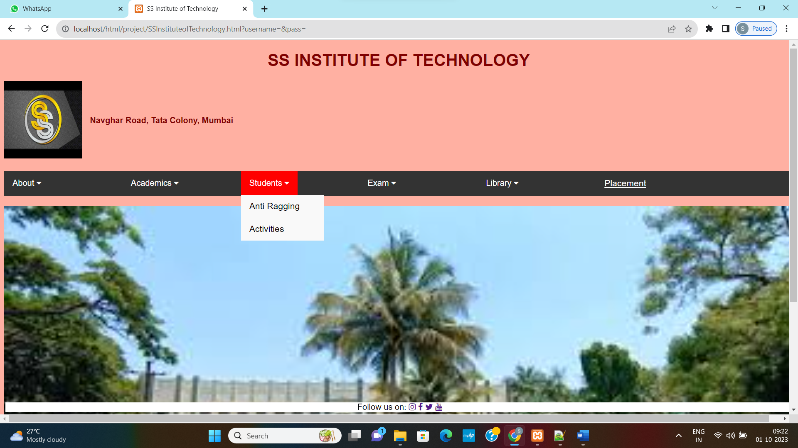

**ANTIRAGGING**

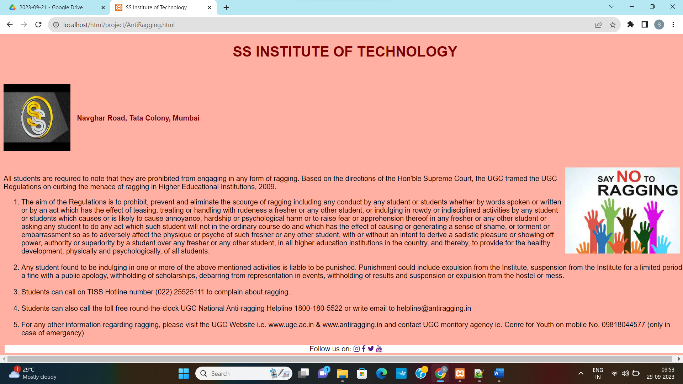

**ACTIVITIES**

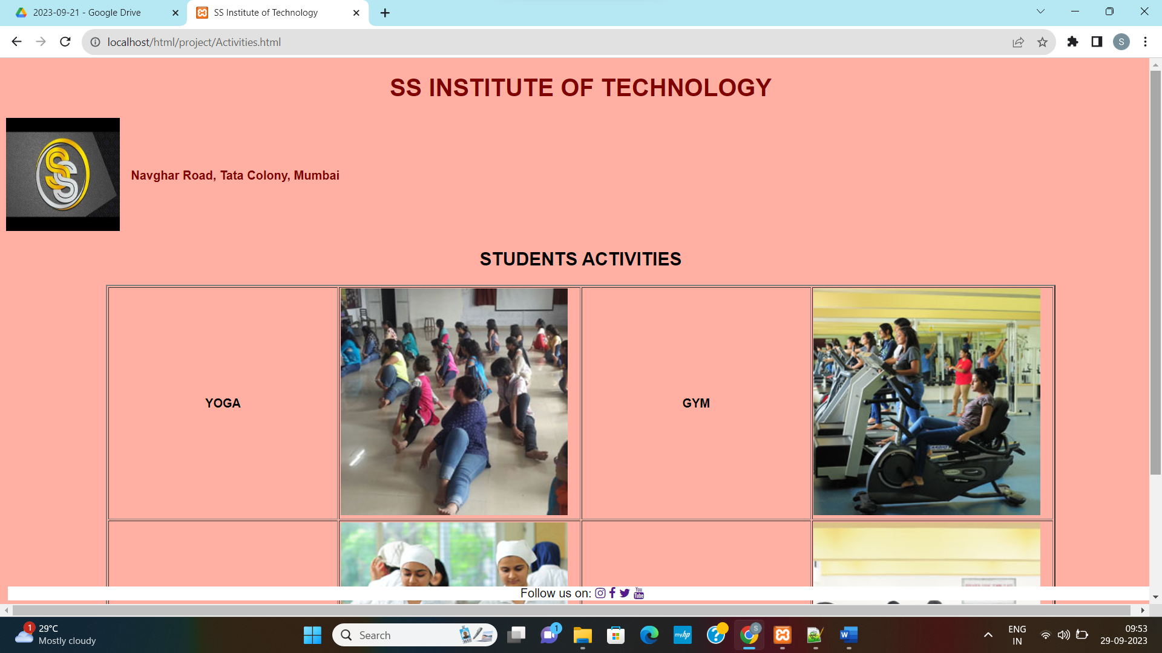

**EXAM**

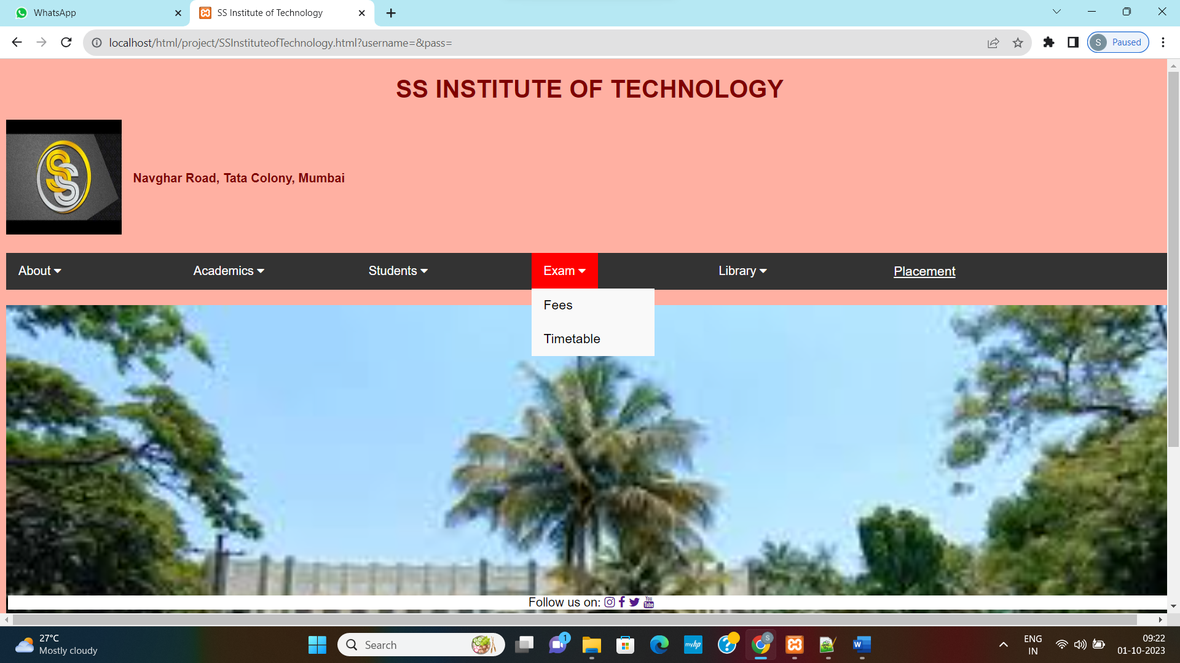

**FEES**

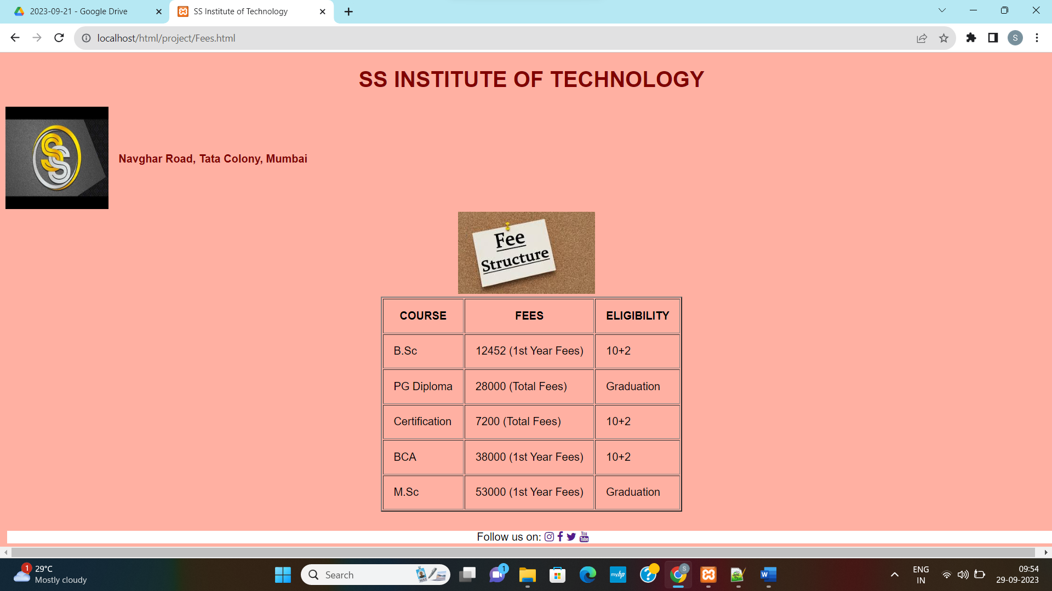

**TIMETABLE**

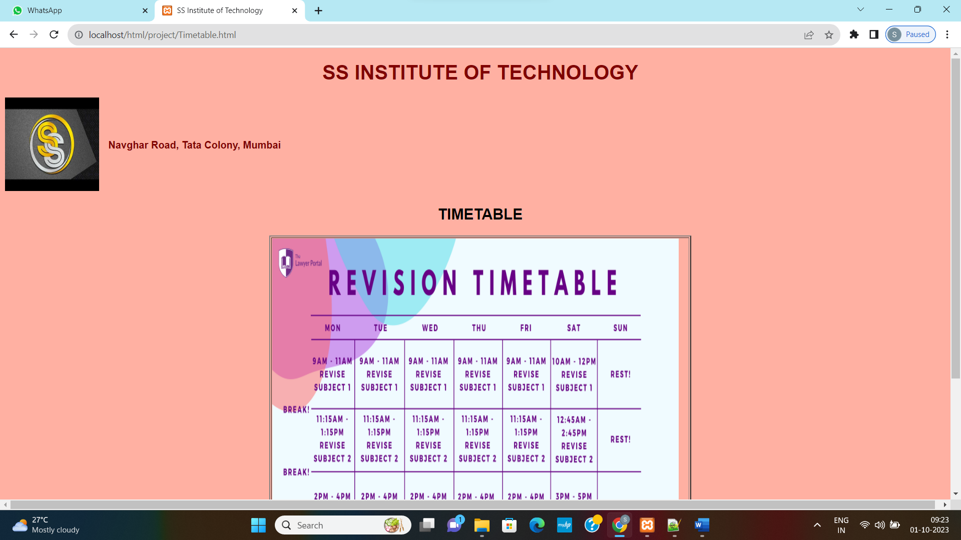

**LIBRARY**

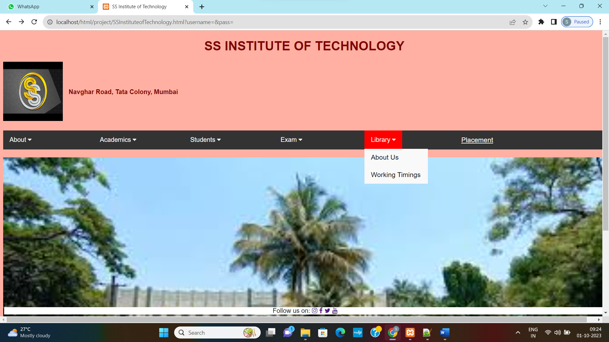

**ABOUT LIBRARY**

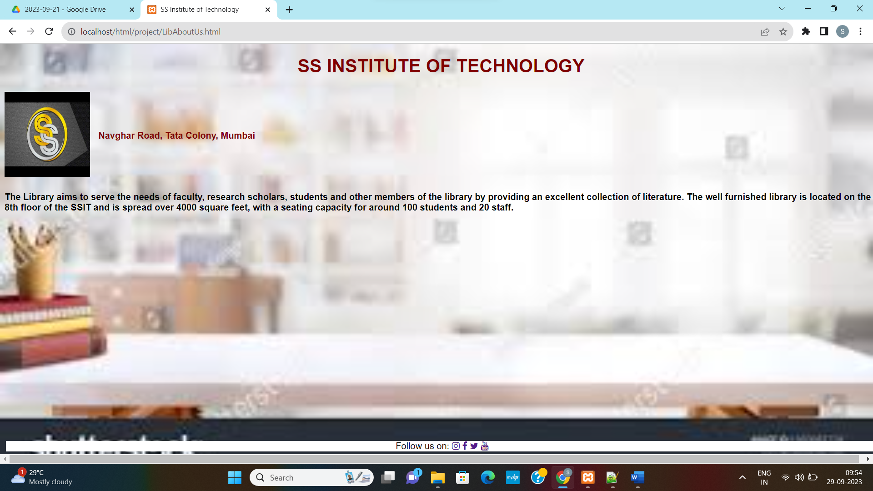

**LIBRARY TIMINGS**

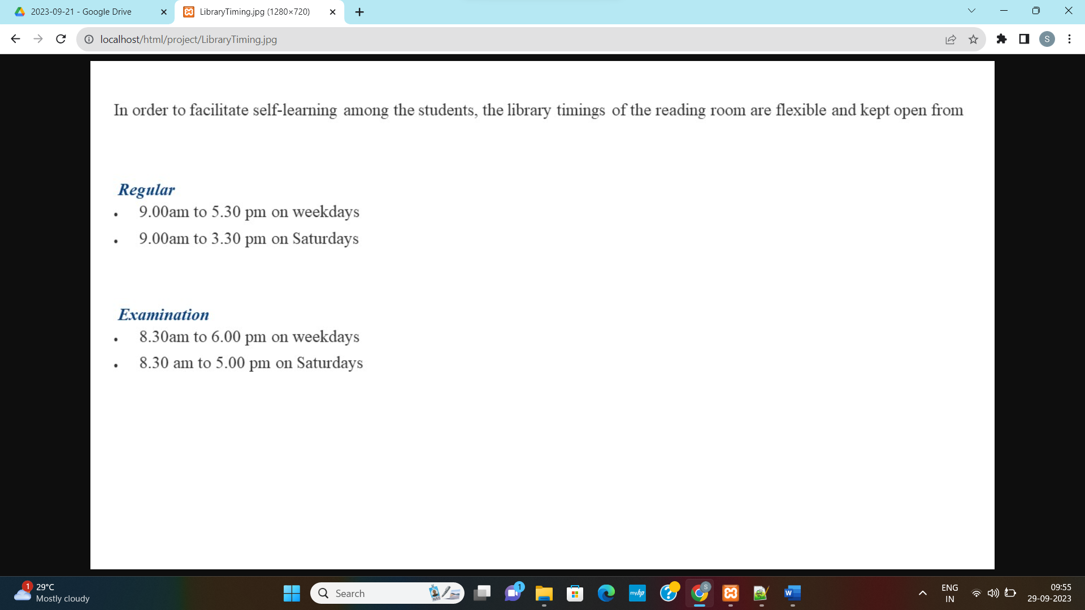

**PLACEMENT**

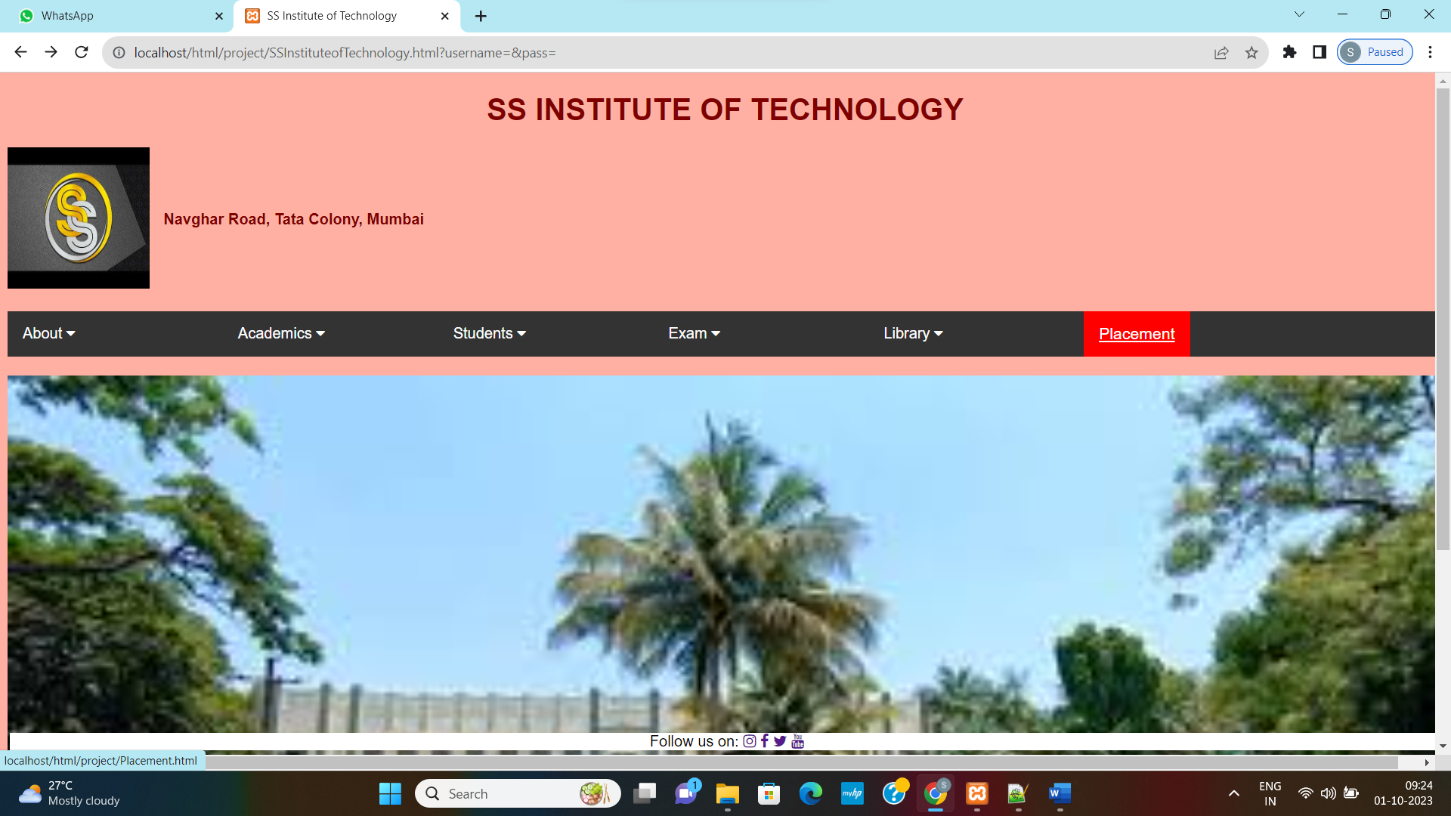

**PLACEMENT INFORMATION**

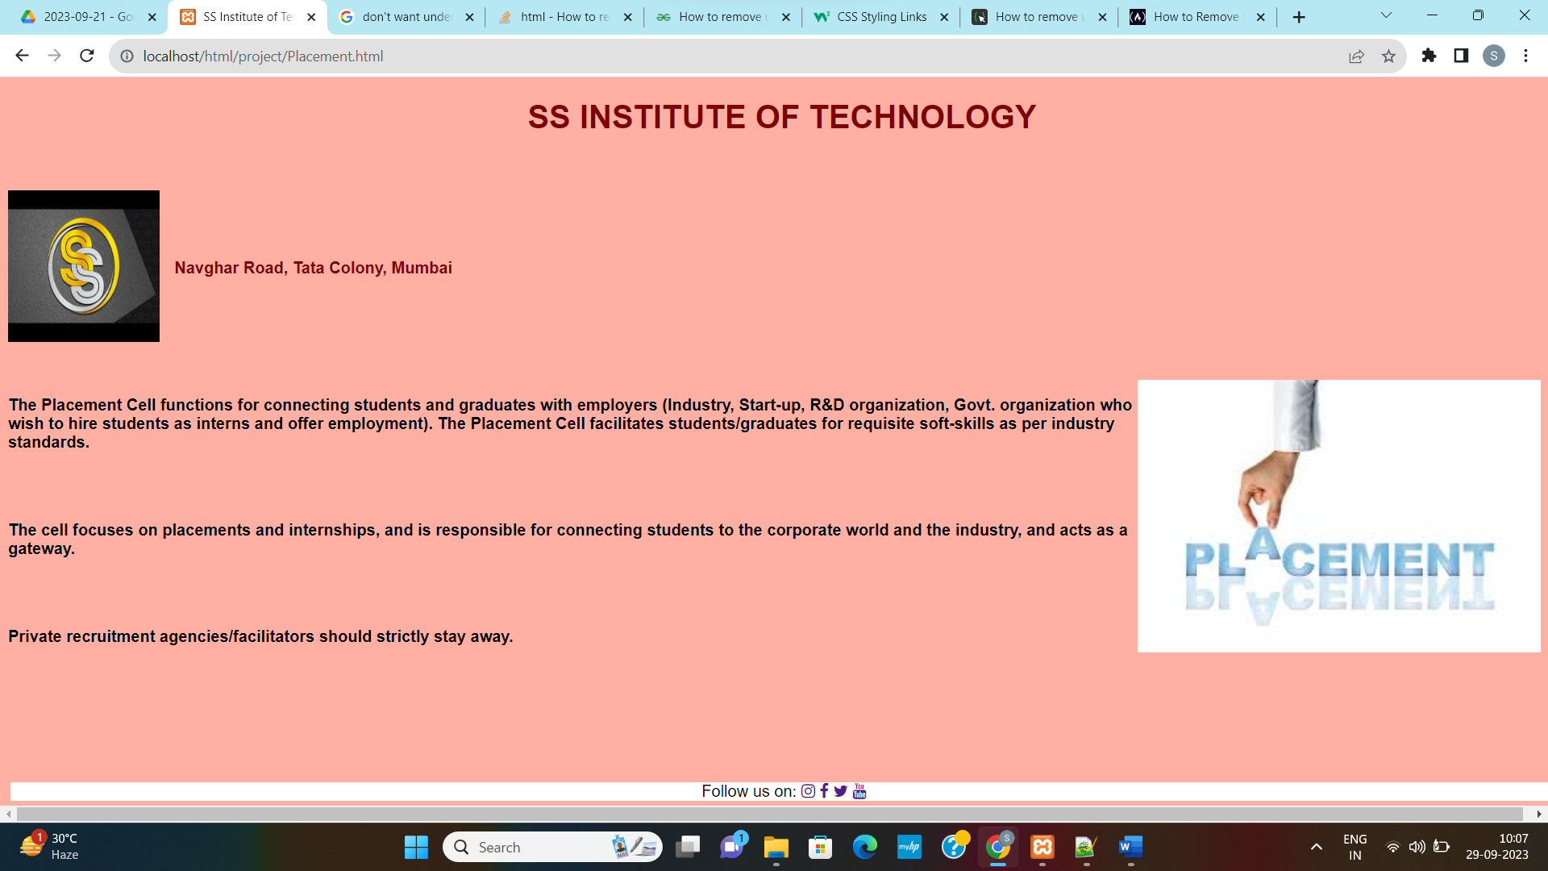

**SSInstituteofTechnology.html**

**<!DOCTYPE html>**

**<html>**

**<head>**

**<title>SS Institute of Technology</title>**

**<meta name="viewport" content="width=device-width, initial-scale=1">**

**<link rel="stylesheet" href="https://cdnjs.cloudflare.com/ajax/libs/font-awesome/4.7.0/css/font-awesome.min.css">**

**<link rel="stylesheet" href="SSInstituteofTechnology.css">**

**</head>**

**<body style="background-color:rgba(255, 99, 71, 0.5);">**

**<div class="heading">**

**<h1><center>SS INSTITUTE OF TECHNOLOGY</center></h1>**

**</div>**

**<div class="container">**

**<div class="image">**

**<img src="sslogo.jpg" width="150px" height="150px">**

**</div>**

**<div class="text">**

**<h4> Navghar Road, Tata Colony, Mumbai</h4>**

**</div>**

**<br><br>**

**</div>**

**<div class="navbar">**

**<div class="dropdown">**

**<button class="dropbtn">About**

**<i class="fa fa-caret-down"></i>**

**</button>**

**<div class="dropdown-content">**

**<a href="AboutUs.html">About Us</a>**

**<a href="InstitutionalValues.html">Institutional Values</a>**

**<a href="PrincipalMessage.html">Principal's Message</a>**

**<a href="VisionandMission.html">Vision and Mission</a>**

**</div>**

**</div>**

**<div class="dropdown">**

**<button class="dropbtn">Academics**

**<i class="fa fa-caret-down"></i>**

**</button>**

**<div class="dropdown-content">**

**<a href="Undergraduate.html">UG Programme</a>**

**<a href="PostGraduate.html">PG Programme</a>**

**<a href="#">Faculty</a>**

**</div>**

**</div>**

**<div class="dropdown">**

**<button class="dropbtn">Students**

**<i class="fa fa-caret-down"></i>**

**</button>**

**<div class="dropdown-content">**

**<a href="AntiRagging.html">Anti Ragging</a>**

**<a href="Activities.html">Activities</a>**

**</div>**

**</div>**

**<div class="dropdown">**

**<button class="dropbtn">Exam**

**<i class="fa fa-caret-down"></i>**

**</button>**

**<div class="dropdown-content">**

**<a href="Fees.html">Fees</a>**

**<a href="#">Timetable</a>**

**</div>**

**</div>**

**<div class="dropdown">**

**<button class="dropbtn">Library**

**<i class="fa fa-caret-down"></i>**

**</button>**

**<div class="dropdown-content">**

**<a href="LibAboutUs.html">About Us</a>**

**<a href="LibraryTiming.jpg">Working Timings</a>**

**</div>**

**</div>**

**<div class="placement">**

**<a href="Placement.html">Placement</a>**

**</div>**

**</div>**

**<div>**

**<img src="College.jpg" width=100% heigth=100%/>**

**</div>**

**<div class="footer">**

**Follow us on:**

**<a href=""><i class="fa fa-instagram"></i></a>**

**<a href=""><i class="fa fa-facebook"></i></a>**

**<a href=""><i class="fa fa-twitter"></i></a>**

**<a href=""><i class="fa fa-youtube"></i></a>**

**</div>**

**</body>**

**</html>**

**SSInstituteofTechnology.css**

**/* Styling for the heading of the Webpage*/**

**.heading{**

**color:maroon;**

**}**

**/* Styling for the body of the Webpage with the properties font-family, width and background-repeat. This is Tag Selector */**

**body**

**{**

**font-family: Arial, Helvetica, sans-serif; /* Multiple fonts. If browser does not support first font it will go for other font */**

**width: 100%;**

**background-repeat: no-repeat; /* Background Image should not repeat */**

**}**

**/* Styling Navigation Bar. This is Class Selector */**

**.navbar**

**{**

**overflow: hidden; /* if the content overflows then this property either clips the content or add scrollbar */**

**background-color: #333; /* hex Color*/**

**width: 100%;**

**margin: 20px 0; /* It specifies top and bottom margin as 20px and right and left as 0 margin */**

**}**

**/* Styling Links inside the Navigation Bar. This is Class Selector */**

**.navbar a**

**{**

**float: left; /* It will display link left side */**

**font-size: 17px;**

**color: white;**

**text-align: center;**

**padding: 14px 16px; /* It specifies spacing between the content and border. It gives space for top and bottom as 14px and right and left as 16px */**

**}**

**/* Styling Dropdown Menu. This is Class Selector */**

**.dropdown**

**{**

**float: left;**

**overflow: hidden;**

**width: 15%;**

**}**

**/* Styling Dropdown Button. This is Class Selector */**

**.dropdown .dropbtn**

**{**

**font-size: 16px;**

**border: none;**

**color: white;**

**padding: 14px 16px;**

**background-color: inherit; /* Inherits the Backgorund Color from the Parent */**

**font-family: inherit; /* Inherits the Font Family from the Parent */**

**}**

**/* Styling for Navigation Bar links on Hover. It will give background color as red on Hover. This is Class Selector */**

**.navbar a:hover, .dropdown:hover .dropbtn**

**{**

**background-color: red;**

**}**

**/* Styling for Dropdown Content. This is Class Selector */**

**.dropdown-content**

**{**

**display: none;**

**position: absolute; /* The position of the Dropdown Content is Absolute */**

**background-color: #f9f9f9;**

**min-width: 160px; /* Minimum Width */**

**}**

**/* Styling for Links inside the Dropdown. This is Class Selector */**

**.dropdown-content a**

**{**

**float: none;**

**color: black;**

**padding: 12px 16px;**

**text-decoration: none;**

**display: block;**

**text-align: left;**

**}**

**/* Styling for Dropdown links on Hover. It adds grey color to the Background. This is Class Selector */**

**.dropdown-content a:hover**

**{**

**background-color: #ddd;**

**}**

**/* Styling for Dropdown Menu on Hover. This is Class Selector */**

**.dropdown:hover .dropdown-content**

**{**

**display: block;**

**}**

**/* Styling for Footer. This is Class Selector */**

**.footer**

**{**

**position: fixed; /* Position of the Footer will be fixed */**

**left: 10px;**

**bottom: 5px;**

**right: 50px;**

**width: 100%;**

**background-color: white;**

**color: black;**

**text-align: center;**

**}**

**/* Styling for the first section of the Webpage. This is Class Selector */**

**.container**

**{**

**display: flex;**

**align-items: center;**

**justify-content: left;**

**color: maroon;**

**}**

**/* Styling for Image in the first section of the Webpage. This is Tag Selector*/**

**img**

**{**

**max-width: 100%;**

**max-height:100%;**

**margin-right: 15px;**

**}**

**/* Styling for Placement. This is Class Selector*/**

**.placement**

**{**

**text-decoration: none;**

**}**

**AboutUs.html**

**<!DOCTYPE html>**

**<html>**

**<head>**

**<title>SS Institute of Technology</title>**

**<meta name="viewport" content="width=device-width, initial-scale=1">**

**<link rel="stylesheet" href="https://cdnjs.cloudflare.com/ajax/libs/font-awesome/4.7.0/css/font-awesome.min.css">**

**<link rel="stylesheet" href="SSInstituteofTechnology.css">**

**</head>**

**<body style="background-color:rgba(255, 99, 71, 0.5);">**

**<div class="heading">**

**<h1><center>SS INSTITUTE OF TECHNOLOGY</center></h1>**

**</div>**

**<div class="container">**

**<div class="image">**

**<img src="sslogo.jpg" width="150px" height="150px">**

**</div>**

**<div class="text">**

**<h4> Navghar Road, Tata Colony, Mumbai</h4>**

**</div>**

**<br><br><br><br><br><br><br><br><br><br><br><br>**

**</div>**

**<div>**

**<p><b>**

**SS Institute of Technology (Autonomous) established in 1984, has always sought to be a pioneer in academic pursuits. The college was re-accredited by National Assessment & Accreditation Council (NAAC) with A+ Grade and CGPA 3.69/4. In May 2016 we received UGC status of College with Potential for Excellence. In July 2017 we received best college award from University.**

**</b></p>**

**<br><br>**

**<p><b>**

**Our college has been among the few prestigious colleges in Mumbai to have received a sanction of Rs 5 crore grant from Rashtriya Uchchatar Shiksha Abhiyan (RUSA) under the "Enhancing Quality and Excellence in Select Autonomous colleges Scheme". - RUSA 2.8. RUSA is a centrally sponsored holistic scheme ( CSS) , launched in 2013. It aims at providing strategic funding to eligible State Higher Educational Institutions.**

**</b></p>**

**</div>**

**<div class="footer">**

**Follow us on:**

**<a href=""><i class="fa fa-instagram"></i></a>**

**<a href=""><i class="fa fa-facebook"></i></a>**

**<a href=""><i class="fa fa-twitter"></i></a>**

**<a href=""><i class="fa fa-youtube"></i></a>**

**</div>**

**</body>**

**</html>**

**InstitutionalValues.html**

**<!DOCTYPE html>**

**<html>**

**<head>**

**<title>SS Institute of Technology</title>**

**<meta name="viewport" content="width=device-width, initial-scale=1">**

**<link rel="stylesheet" href="https://cdnjs.cloudflare.com/ajax/libs/font-awesome/4.7.0/css/font-awesome.min.css">**

**<link rel="stylesheet" href="SSInstituteofTechnology.css">**

**</head>**

**<body style="background-color:rgba(255, 99, 71, 0.5);">**

**<div class="heading">**

**<h1><center>SS INSTITUTE OF TECHNOLOGY</center></h1>**

**</div>**

**<div class="container">**

**<div class="image">**

**<img src="sslogo.jpg" width="150px" height="150px">**

**</div>**

**<div class="text">**

**<h4> Navghar Road, Tata Colony, Mumbai</h4>**

**</div>**

**<br><br><br><br><br><br><br><br><br><br><br><br>**

**</div>**

**<div style="float: right;">**

**<img src="institutionalvalues.jpeg"/>**

**</div>**

**<div>**

**<ol>**

**<li><b>**

**Integrity is defined as the quality of being honest and having strong moral principles. In an educational institution, where the sole aim of the organisation is to life the mindset of the students to soar new heights, integrity is of paramount importance. SS Institute of Technology takes pride in working with integrity and a sense of righteousness to hold itself to consistent moral and ethical standards.**

**</b></li>**

**<br><br><br>**

**<li><b>**

**Excellence is the hallmark of consistency. SS Institute of Technology has consistently ranked among the top educational institutions in the city and state. It currently occupies a position in the 101 to 150 bracket of the National Institute Ranking Framework (NIRF). All this has been possible with dedicated input from the management and faculty members, who consistently try to mould the institution towards constant improvement and progress.**

**</b></li>**

**<br><br><br>**

**<li><b>**

**The prime goal of an educational institution like SS Institute of Technology, strives to make the society better in all respects by providing quality education. One of the highlights of the new curriculum under autonomy has been to provide relevant education that would make a difference to the society. The institution also tries to instill the values of social service among its students and faculty members by being a part of various social welfare schemes, and tie-ups with NGOs from time to time.**

**</b></li>**

**<br><br><br>**

**<li><b>**

**The whole universe is our family. With a strong belief in Vasudev Kutumbakam, SS Institute of Technology extends its services in education to one and all without any discrimination on any grounds whatsoever. It strives to consistently uplift the standard of education provided, with relevance to the current global trends and standards.**

**</b></li>**

**</ol>**

**</div>**

**<div class="footer">**

**Follow us on:**

**<a href=""><i class="fa fa-instagram"></i></a>**

**<a href=""><i class="fa fa-facebook"></i></a>**

**<a href=""><i class="fa fa-twitter"></i></a>**

**<a href=""><i class="fa fa-youtube"></i></a>**

**</div>**

**</body>**

**</html>**

**PrincipalMessage.html**

**<!DOCTYPE html>**

**<html>**

**<head>**

**<title>SS Institute of Technology</title>**

**<meta name="viewport" content="width=device-width, initial-scale=1">**

**<link rel="stylesheet" href="https://cdnjs.cloudflare.com/ajax/libs/font-awesome/4.7.0/css/font-awesome.min.css">**

**<link rel="stylesheet" href="SSInstituteofTechnology.css">**

**</head>**

**<body style="background-color:rgba(255, 99, 71, 0.5);">**

**<div class="heading">**

**<h1><center>SS INSTITUTE OF TECHNOLOGY</center></h1>**

**</div>**

**<div class="container">**

**<div class="image">**

**<img src="sslogo.jpg" width="150px" height="150px">**

**</div>**

**<div class="text">**

**<h4> Navghar Road, Tata Colony, Mumbai</h4>**

**</div>**

**<br><br><br><br><br><br><br><br><br><br><br><br>**

**</div>**

**<div>**

**<p><b>**

**I have great pleasure in expressing my thoughts as the Principal of SS Institute of Technology (SSIT), the Numero Uno, self-financed, autonomous Institution of Maharashtra. We are not just a conglomeration of more than 300 institutions, but a culture, a saga, a holy journey, started by Dr. K.M. Munshi with the support of Mahatma Gandhi in 1938. Imparting value-based education with Indian cultural ethos has always been the motto of SS.**

**</b></p>**

**<p><b>**

**Engineers and technologists form the backbone of any nations economic development. The world is presently undergoing very unprecedented, extraordinary, challenging time. A new normal is anticipated in many walks of life, including education. Such disruptions will come again and again in one or the other form. Engineers will work for 40-50 years of their life, they will have 3 to 4 diversified careers in technologies we are even unaware of. To make aspiring minds confident and future-proof, education must prepare them for a marathon rather than a sprint. SSIT makes continuous, sincere efforts towards this.**

**</b></p>**

**<p><b>**

**We focus on How to learn rather than What to learn. We believe in multidisciplinary exposure to the learners, yet ensuring growth in one vertical, cherishing human sensitivity and empathy. We have thoughtfully articulated a unique academic model towards this. Our splendid academic performance, sparkling placements (quantitative and qualitative), enrollment for higher studies at the best places of the world, prizes won by our students in national/international level technical competitions, in past many years are the true testimonials for this.**

**</b></p>**

**<p><b>**

**With the support of a dedicated and hardworking faculty and staff, the institute has achieved enviable visibility and ranking in a short span. On behalf of all stakeholders of SSIT, I welcome you to this family and look forward to your valuable association with us for a better tomorrow. Four years of engineering education at SS Institute of Technology or two years post-graduation, will undoubtedly empower you to lead a successful life.**

**</b></p>**

**</div>**

**<div class="footer">**

**Follow us on:**

**<a href=""><i class="fa fa-instagram"></i></a>**

**<a href=""><i class="fa fa-facebook"></i></a>**

**<a href=""><i class="fa fa-twitter"></i></a>**

**<a href=""><i class="fa fa-youtube"></i></a>**

**</div>**

**</body>**

**</html>**

**VisionandMission.html**

**<!DOCTYPE html>**

**<html>**

**<head>**

**<title>SS Institute of Technology</title>**

**<meta name="viewport" content="width=device-width, initial-scale=1">**

**<link rel="stylesheet" href="https://cdnjs.cloudflare.com/ajax/libs/font-awesome/4.7.0/css/font-awesome.min.css">**

**<link rel="stylesheet" href="SSInstituteofTechnology.css">**

**</head>**

**<body style="background-color:rgba(255, 99, 71, 0.5);">**

**<div class="heading">**

**<h1><center>SS INSTITUTE OF TECHNOLOGY</center></h1>**

**</div>**

**<div class="container">**

**<div class="image">**

**<img src="sslogo.jpg" width="150px" height="150px">**

**</div>**

**<div class="text">**

**<h4> Navghar Road, Tata Colony, Mumbai</h4>**

**</div>**

**<br><br><br><br><br><br><br><br><br><br><br><br>**

**</div>**

**<div style="float: right;">**

**<img src="visionandmission.png"/>**

**</div>**

**<div>**

**<dl>**

**<dt><b>**

**VISION**

**</b></dt>**

**<br>**

**<dd>**

**Empowerment of Women through Quality in Education.**

**</dd>**

**<br><br><br><br>**

**<dt><b>**

**MISSION**

**</b></dt>**

**<br>**

**<dd>**

**To impart transformational & accessible education that intellectually stimulates and academically empowers women from all sections of society to gain personal strength, build self-reliance, digital competence and enhance entrepreneurial skills to achieve optimum empowerment.**

**</dd>**

**</dl>**

**</div>**

**<div class="footer">**

**Follow us on:**

**<a href=""><i class="fa fa-instagram"></i></a>**

**<a href=""><i class="fa fa-facebook"></i></a>**

**<a href=""><i class="fa fa-twitter"></i></a>**

**<a href=""><i class="fa fa-youtube"></i></a>**

**</div>**

**</body>**

**</html>**

**Undergraduate.html**

**<!DOCTYPE html>**

**<html>**

**<head>**

**<title>SS Institute of Technology</title>**

**<meta name="viewport" content="width=device-width, initial-scale=1">**

**<link rel="stylesheet" href="SSInstituteofTechnology.css">**

**</head>**

**<body style="background-color:rgba(255, 99, 71, 0.5);">**

**<div class="heading">**

**<h1><center>SS INSTITUTE OF TECHNOLOGY</center></h1>**

**</div>**

**<div class="container">**

**<div class="image">**

**<img src="sslogo.jpg" width="150px" height="150px">**

**</div>**

**<div class="text">**

**<h4> Navghar Road, Tata Colony, Mumbai</h4>**

**</div>**

**<br><br><br><br><br>**

**</div>**

**<marquee><h2>UNDERGRADUATE COURSES</h2></marquee>**

**<table border="2" align="center">**

**<tr>**

**<td heigth=300 width=300><center><b>Textile Science and Apparel Design</b></center></td>**

**<td><img src="Textile.jpeg" height=300 width=300/></td>**

**<td heigth=300 width=300><center><b>Resource Management</b></center></td>**

**<td><img src="ResourceManagement.jpeg" height=300 width=300/></td>**

**</tr>**

**<tr>**

**<td heigth=300 width=300><center><b>Human Development</b></center></td>**

**<td><img src="HumanDevelopment.jpeg" height=300 width=300/></td>**

**<td heigth=300 width=300><center><b>BCA</b></td>**

**<td><img src="bca.jpg" height=300 width=300/></center></td>**

**</tr>**

**<tr>**

**<td heigth=300 width=300><center><b>Nutrition and Dietetics</b></center></td>**

**<td><img src="NutritionandDietetics.jpeg" height=300 width=300/></td>**

**<td heigth=300 width=300><center><b>Foundation Courses</b></td>**

**<td><img src="FoundationCourse.png" height=300 width=300/></center></td>**

**</tr>**

**</table>**

**</body>**

**</html>**

**PostGraduate.html**

**<!DOCTYPE html>**

**<html>**

**<head>**

**<title>SS Institute of Technology</title>**

**<meta name="viewport" content="width=device-width, initial-scale=1">**

**<link rel="stylesheet" href="SSInstituteofTechnology.css">**

**</head>**

**<body style="background-color:rgba(255, 99, 71, 0.5);">**

**<div class="heading">**

**<h1><center>SS INSTITUTE OF TECHNOLOGY</center></h1>**

**</div>**

**<div class="container">**

**<div class="image">**

**<img src="sslogo.jpg" width="150px" height="150px">**

**</div>**

**<div class="text">**

**<h4> Navghar Road, Tata Colony, Mumbai</h4>**

**</div>**

**<br><br><br><br><br>**

**</div>**

**<marquee><h2>POSTGRADUATE COURSES</h2></marquee>**

**<table border="2" align="center">**

**<tr>**

**<td heigth=300 width=300><center><b>M.Sc Resource Management (Tourism and Hospitality)</b></center></td>**

**<td><img src="HRM.jpeg" height=300 width=300/></td>**

**<td heigth=300 width=300><center><b>M.Sc Computer Science</b></center></td>**

**<td><img src="MSCCS.jpeg" height=300 width=300/></td>**

**</tr>**

**<tr>**

**<td heigth=300 width=300><center><b>PG Sports Science Fitness and Nutrition</b></center></td>**

**<td><img src="PGFitnessandNutrition.jpeg" height=300 width=300/></td>**

**<td heigth=300 width=300><center><b>Nutrition and Dietetics</b></td>**

**<td><img src="NutritionandDieteticsMsc.jpeg" height=300 width=300/></center></td>**

**</tr>**

**<tr>**

**<td colspan="2" heigth=300 width=300><center><b>PG Early Childhood Education</b></center></td>**

**<td><img src="PGEarlyChildhoodEducation.jpeg" height=300 width=300/></td>**

**</tr>**

**</table>**

**</body>**

**</html>**

**Faculties.html**

**<!DOCTYPE html>**

**<html>**

**<head>**

**<title>SS Institute of Technology</title>**

**<meta name="viewport" content="width=device-width, initial-scale=1">**

**<link rel="stylesheet" href="SSInstituteofTechnology.css">**

**</head>**

**<body style="background-color:rgba(255, 99, 71, 0.5);">**

**<div class="heading">**

**<h1><center>SS INSTITUTE OF TECHNOLOGY</center></h1>**

**</div>**

**<div class="container">**

**<div class="image">**

**<img src="sslogo.jpg" width="150px" height="150px">**

**</div>**

**<div class="text">**

**<h4> Navghar Road, Tata Colony, Mumbai</h4>**

**</div>**

**<br><br><br><br><br>**

**</div>**

**<center><h2>FACULTIES</h2></center>**

**<table border="2" align="center">**

**<tr>**

**<td heigth=300 width=300><center><b>Mr. Akhilesh</b></center>**

**<img src="Akhilesh.jpeg" height=300 width=300/></td>**

**<td heigth=300 width=300><center><b>Ms. Dipa</b></center>**

**<img src="Dipa.png" height=300 width=300/></td>**

**</tr>**

**<tr>**

**<td heigth=300 width=300><center><b>Mr. Rohan</b></center>**

**<img src="Rohan.jpeg" height=300 width=300/></td>**

**<td heigth=300 width=300><center><b>Mr. Shree</b>**

**<img src="Shree.jpg" height=300 width=300/></center></td>**

**</tr>**

**<tr>**

**<td colspan="2" heigth=300 width=300><center><b>Ms. Susan</b></center>**

**<center><img src="Susan.jpeg" height=300 width=300/></center></td>**

**</tr>**

**</table>**

**</body>**

**</html>**

**AntiRagging.html**

**<!DOCTYPE html>**

**<html>**

**<head>**

**<title>SS Institute of Technology</title>**

**<meta name="viewport" content="width=device-width, initial-scale=1">**

**<link rel="stylesheet" href="https://cdnjs.cloudflare.com/ajax/libs/font-awesome/4.7.0/css/font-awesome.min.css">**

**<link rel="stylesheet" href="SSInstituteofTechnology.css">**

**</head>**

**<body style="background-color:rgba(255, 99, 71, 0.5);">**

**<div class="heading">**

**<h1><center>SS INSTITUTE OF TECHNOLOGY</center></h1>**

**</div>**

**<div class="container">**

**<div class="image">**

**<img src="sslogo.jpg" width="150px" height="150px">**

**</div>**

**<div class="text">**

**<h4> Navghar Road, Tata Colony, Mumbai</h4>**

**</div>**

**<br><br><br><br><br><br><br><br><br><br><br><br>**

**</div>**

**<div style="float: right;">**

**<img src="antiragging.jpeg" alt="Image description">**

**</div>**

**<p>All students are required to note that they are prohibited from engaging in any form of ragging. Based on the directions of the Hon'ble Supreme Court, the UGC framed the UGC Regulations on curbing the menace of ragging in Higher Educational Institutions, 2009.**

**</p>**

**<ol>**

**<li>**

**The aim of the Regulations is to prohibit, prevent and eliminate the scourge of ragging including any conduct by any student or students whether by words spoken or written or by an act which has the effect of teasing, treating or handling with rudeness a fresher or any other student, or indulging in rowdy or indisciplined activities by any student or students which causes or is likely to cause annoyance, hardship or psychological harm or to raise fear or apprehension thereof in any fresher or any other student or asking any student to do any act which such student will not in the ordinary course do and which has the effect of causing or generating a sense of shame, or torment or embarrassment so as to adversely affect the physique or psyche of such fresher or any other student, with or without an intent to derive a sadistic pleasure or showing off power, authority or superiority by a student over any fresher or any other student, in all higher education institutions in the country, and thereby, to provide for the healthy development, physically and psychologically, of all students.**

**</li>**

**<br>**

**<li>**

**Any student found to be indulging in one or more of the above mentioned activities is liable to be punished. Punishment could include expulsion from the Institute, suspension from the Institute for a limited period, a fine with a public apology, withholding of scholarships, debarring from representation in events, withholding of results and suspension or expulsion from the hostel or mess.**

**</li>**

**<br>**

**<li>**

**Students can call on TISS Hotline number (022) 25525111 to complain about ragging.**

**</li>**

**<br>**

**<li>**

**Students can also call the toll free round-the-clock UGC National Anti-ragging Helpline 1800-180-5522 or write email to helpline@antiragging.in**

**</li>**

**<br>**

**<li>**

**For any other information regarding ragging, please visit the UGC Website i.e. www.ugc.ac.in & www.antiragging.in and contact UGC monitory agency ie. Cenre for Youth on mobile No. 09818044577 (only in case of emergency)**

**</li>**

**</ol>**

**</div>**

**<div class="footer">**

**Follow us on:**

**<a href=""><i class="fa fa-instagram"></i></a>**

**<a href=""><i class="fa fa-facebook"></i></a>**

**<a href=""><i class="fa fa-twitter"></i></a>**

**<a href=""><i class="fa fa-youtube"></i></a>**

**</div>**

**</body>**

**</html>**

**Activities.html**

**<!DOCTYPE html>**

**<html>**

**<head>**

**<title>SS Institute of Technology</title>**

**<meta name="viewport" content="width=device-width, initial-scale=1">**

**<link rel="stylesheet" href="SSInstituteofTechnology.css">**

**</head>**

**<body style="background-color:rgba(255, 99, 71, 0.5);">**

**<div class="heading">**

**<h1><center>SS INSTITUTE OF TECHNOLOGY</center></h1>**

**</div>**

**<div class="container">**

**<div class="image">**

**<img src="sslogo.jpg" width="150px" height="150px">**

**</div>**

**<div class="text">**

**<h4> Navghar Road, Tata Colony, Mumbai</h4>**

**</div>**

**<br><br><br><br><br>**

**</div>**

**<center><h2>STUDENTS ACTIVITIES</h2></center>**

**<table border="2" align="center">**

**<tr>**

**<td heigth=300 width=300><center><b>YOGA</b></center></td>**

**<td><img src="Yoga.jpg" height=300 width=300/></td>**

**<td heigth=300 width=300><center><b>GYM</b></center></td>**

**<td><img src="gym.jpg" height=300 width=300/></td>**

**</tr>**

**<tr>**

**<td heigth=300 width=300><center><b>COOKING</b></center></td>**

**<td><img src="Cooking.jpg" height=300 width=300/></td>**

**<td heigth=300 width=300><center><b>STICHING</b></td>**

**<td><img src="Stiching.jpg" height=300 width=300/></center></td>**

**</tr>**

**</table>**

**</body>**

**</html>**

**Fees.html**

**<!DOCTYPE html>**

**<html>**

**<head>**

**<title>SS Institute of Technology</title>**

**<meta name="viewport" content="width=device-width, initial-scale=1">**

**<link rel="stylesheet" href="https://cdnjs.cloudflare.com/ajax/libs/font-awesome/4.7.0/css/font-awesome.min.css">**

**<link rel="stylesheet" href="SSInstituteofTechnology.css">**

**</head>**

**<body style="background-color:rgba(255, 99, 71, 0.5);">**

**<div class="heading">**

**<h1><center>SS INSTITUTE OF TECHNOLOGY</center></h1>**

**</div>**

**<div class="container">**

**<div class="image">**

**<img src="sslogo.jpg" width="150px" height="150px">**

**</div>**

**<div class="text">**

**<h4> Navghar Road, Tata Colony, Mumbai</h4>**

**</div>**

**<br><br><br><br><br><br><br><br>**

**</div>**

**<center><img src="Fees.jpeg" width="200px" heigth="200px"></center>**

**<table border="2" align="center" cellpadding="15px">**

**<tr>**

**<th>COURSE</th>**

**<th>FEES</th>**

**<th>ELIGIBILITY</th>**

**</tr>**

**<tr>**

**<td>B.Sc</td>**

**<td>12452 (1st Year Fees)</td>**

**<td>10+2</td>**

**</tr>**

**<tr>**

**<td>PG Diploma</td>**

**<td>28000 (Total Fees)</td>**

**<td>Graduation</td>**

**</tr>**

**<tr>**

**<td>Certification</td>**

**<td>7200 (Total Fees)</td>**

**<td>10+2</td>**

**</tr>**

**<tr>**

**<td>BCA</td>**

**<td>38000 (1st Year Fees)</td>**

**<td>10+2</td>**

**</tr>**

**<tr>**

**<td>M.Sc</td>**

**<td>53000 (1st Year Fees)</td>**

**<td>Graduation</td>**

**</tr>**

**</table>**

**<div class="footer">**

**Follow us on:**

**<a href=""><i class="fa fa-instagram"></i></a>**

**<a href=""><i class="fa fa-facebook"></i></a>**

**<a href=""><i class="fa fa-twitter"></i></a>**

**<a href=""><i class="fa fa-youtube"></i></a>**

**</div>**

**</body>**

**</html>**

**Timetable.html**

**<!DOCTYPE html>**

**<html>**

**<head>**

**<title>SS Institute of Technology</title>**

**<meta name="viewport" content="width=device-width, initial-scale=1">**

**<link rel="stylesheet" href="SSInstituteofTechnology.css">**

**</head>**

**<body style="background-color:rgba(255, 99, 71, 0.5);">**

**<div class="heading">**

**<h1><center>SS INSTITUTE OF TECHNOLOGY</center></h1>**

**</div>**

**<div class="container">**

**<div class="image">**

**<img src="sslogo.jpg" width="150px" height="150px">**

**</div>**

**<div class="text">**

**<h4> Navghar Road, Tata Colony, Mumbai</h4>**

**</div>**

**<br><br>**

**</div>**

**<center><h2>TIMETABLE</h2></center>**

**<table border="2" align="center">**

**<tr>**

**<td><img src="Timetable.png" height=650 width=650/></td>**

**</tr>**

**</table>**

**</body>**

**</html>**

**LibAboutUs,html**

**<!DOCTYPE html>**

**<html>**

**<head>**

**<title>SS Institute of Technology</title>**

**<meta name="viewport" content="width=device-width, initial-scale=1">**

**<link rel="stylesheet" href="https://cdnjs.cloudflare.com/ajax/libs/font-awesome/4.7.0/css/font-awesome.min.css">**

**<link rel="stylesheet" href="SSInstituteofTechnology.css">**

**</head>**

**<body style="background-color:rgba(255, 99, 71, 0.5); background-image:url('library.jpeg'); background-repeat:no-repeat; background-size:cover;">**

**<div class="heading">**

**<h1><center>SS INSTITUTE OF TECHNOLOGY</center></h1>**

**</div>**

**<div class="container">**

**<div class="image">**

**<img src="sslogo.jpg" width="150px" height="150px">**

**</div>**

**<div class="text">**

**<h4>Navghar Road, Tata Colony, Mumbai</h4>**

**</div>**

**<br><br><br><br><br><br><br><br><br>**

**</div>**

**<div>**

**<p><b>**

**The Library aims to serve the needs of faculty, research scholars, students and other members of the library by providing an excellent collection of literature. The well furnished library is located on the 8th floor of the SSIT and is spread over 4000 square feet, with a seating capacity for around 100 students and 20 staff.**

**</b></p>**

**<p>**

**<img src=""/>**

**</p>**

**</div>**

**<div class="footer">**

**Follow us on:**

**<a href=""><i class="fa fa-instagram"></i></a>**

**<a href=""><i class="fa fa-facebook"></i></a>**

**<a href=""><i class="fa fa-twitter"></i></a>**

**<a href=""><i class="fa fa-youtube"></i></a>**

**</div>**

**</body>**

**</html>**

**Placement.html**

**<!DOCTYPE html>**

**<html>**

**<head>**

**<title>SS Institute of Technology</title>**

**<meta name="viewport" content="width=device-width, initial-scale=1">**

**<link rel="stylesheet" href="https://cdnjs.cloudflare.com/ajax/libs/font-awesome/4.7.0/css/font-awesome.min.css">**

**<link rel="stylesheet" href="SSInstituteofTechnology.css">**

**</head>**

**<body style="background-color:rgba(255, 99, 71, 0.5);">**

**<div class="heading">**

**<h1><center>SS INSTITUTE OF TECHNOLOGY</center></h1>**

**</div>**

**<div class="container">**

**<div class="image">**

**<img src="sslogo.jpg" width="150px" height="150px">**

**</div>**

**<div class="text">**

**<h4> Navghar Road, Tata Colony, Mumbai</h4>**

**</div>**

**<br><br><br><br><br><br><br><br><br><br><br><br>**

**</div>**

**<div style="float: right;">**

**<img src="placement.jpeg" width="400px" heigth="400px"/>**

**</div>**

**<div>**

**<p><b>**

**The Placement Cell functions for connecting students and graduates with employers (Industry, Start-up, R&D organization, Govt. organization who wish to hire students as interns and offer employment).**

**The Placement Cell facilitates students/graduates for requisite soft-skills as per industry standards.**

**</b></p>**

**<br><br>**

**<p><b>**

**The cell focuses on placements and internships, and is responsible for connecting students to the corporate world and the industry, and acts as a gateway.**

**</b></p>**

**<br><br>**

**<p><b>**

**Private recruitment agencies/facilitators should strictly stay away.**

**</b></p>**

**</div>**

**<div class="footer">**

**Follow us on:**

**<a href=""><i class="fa fa-instagram"></i></a>**

**<a href=""><i class="fa fa-facebook"></i></a>**

**<a href=""><i class="fa fa-twitter"></i></a>**

**<a href=""><i class="fa fa-youtube"></i></a>**

**</div>**

**</body>**

**</html>**